Contents

INTRODUCTION: 2

How bird’s feathers are colorful: 3

PIGMENTATION: 3

Color Abnormalities: 4

Birds that have colourfull feathers: 5

Albatross – 6

Booby – 7

**Depart: zoology**

**Bs (I)**

Group member’s names

1: toOBA zainab

2 : beenish khan

3 : lamiah mansoor

4 : mehak rafiq

5 : alina amjad ali

6 : rohma abid

**TOPIC : COLOUR PIGMENTATION**

# INTRODUCTION:

Biological pigments, also known simply as pigments or biochromes.they are substances produced by living organisms that have a color resulting from selective color absorption. Biological pigments include plant pigments and colorful birds. Many biological structures, such as skin, eyes, feathers, fur and hair contain pigments such as melanin in specialized cells calledchromatophores.

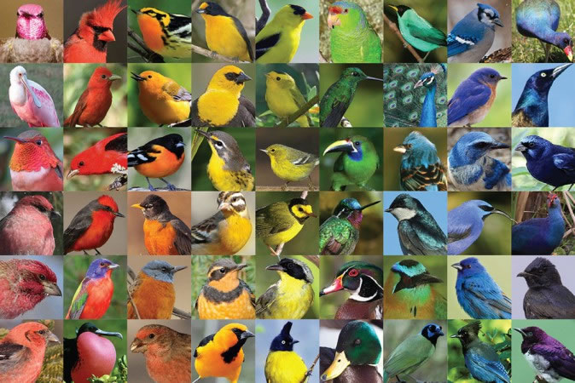

How bird’s feathers are colorful:

As one might expect from the amazing diversity of colors and patterns exhibited by more than 9,000 bird species found in the world, birds can see color. The colors in the feathers of a bird are formed in two different ways, from either pigments or from light refraction caused by the structure of the feather. In some cases feather colors are the result of a combination of pigment and structural colors. The greens of some parrots are the result of yellow pigments overlying the blue-reflecting characteristic of the feathers.

# PIGMENTATION:

Pigments are colored substances that can be found in both plants and animals. The coloration created by pigments is independent of the structure of the feather. Pigment colorization in birds comes from three different groups: carotenoids, melanin’s, and porphyrines.

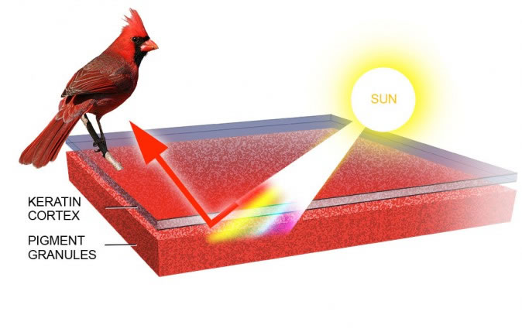

*The microstructure of a pigmented feather. In this case, all but the red wavelengths are absorbed by the pigment granules: Andrew Leach*

# Color Abnormalities:

Two American Crows, the bird on the right has lower than normal levels of melanin pigments: Kevin J. McGowan

When pigments are present (or absent) at unusual levels the appearance of a bird can change dramatically. Color abnormalities, while not common, do occur on a regular basis. Bird species that commonly show aberrant white patches include Canada Goose, American Crow, Black-capped Chickadee, Dark-eyed Junco, Common Grackle, and House Sparrow.

Ultraviolet Feathers: The feather structures of many species also reflect light in the ultraviolet range. Because many birds can discriminate a greater variety of colors than humans, including ultraviolet wavelengths, they can appear quite different to each other than they do to us.

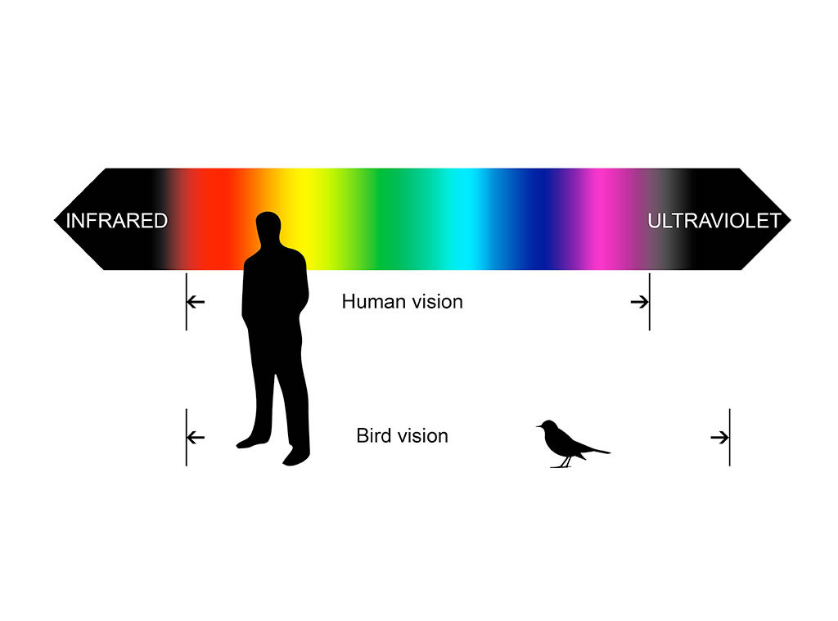

*The range of wavelengths that a typical bird can see compared with the range for humans: Andrew Leach*

# Birds that have colourfull feathers:

Following are some of them:

**Wilson's bird-of-paradise  
albatross  
booby** *.*

[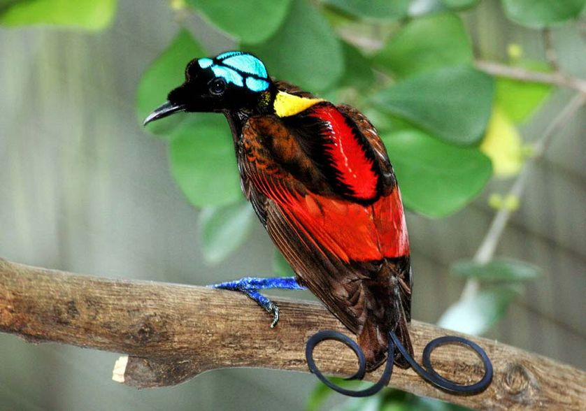](http://media.mnn.com/assets/images/2015/08/Wilson's_Bird_of_Paradise_Best.jpg.838x0_q80.jpg)

A **Wilson's bird-of-paradise**

Tail doesn’t have to be exceptionally long — it can also be exceptionally well styled. Such is the case with the tail feathers of the Wilson’s bird-of-paradise. The unusual appearance of the bird, starting with its naked blue head, is made all the more interesting by the two violet tail feathers that curl in opposite directions. The bird was filmed in the wild for the first time as recently as 1996.

Albatross – It is a both a rainforest and seabird that depends on fishes for food. In size it looks like a combination of a gull, pelican and parrot. It is one of the most gorgeous tropical birds you’ll ever see. It has dark grey shade on the face and head side and light grey feathers with white spots at the bottom. They are surprisingly one of those rare birds that live to long age, and still declared endangered.

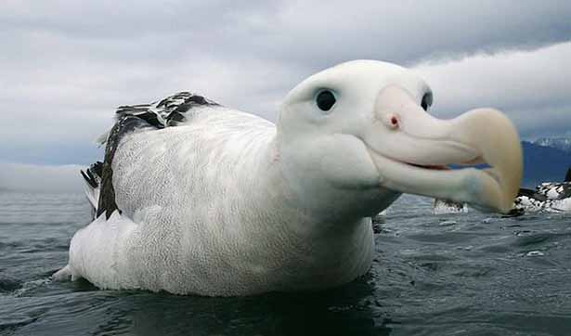

Booby – This is one of those rare tropical birds that can swim, fly and swoop to hunt for food. It’s a seabird that quite a large bird and can be as big as pelicans. The bird has a long beak that helps it catch fishes easily. With smooth plumage, wide and long wings, and duck Foot pigmentation

The blue color of the blue-footed booby's webbed feet comes from carotenoid pigments obtained from its diet of fresh fish. Carotenoids act as antioxidants and stimulants for the blue-footed booby's immune function, suggesting that carotenoid-pigmentation is an indicator of an individual's immunological state.[13] Blue feet also indicate the current health condition of a booby. Boobies who were experimentally food-deprived for forty-eight hours experienced a decrease in foot brightness due to a reduction in the amount of lipids and lipoproteins that are used to absorb and transport carotenoids. Thus, the feet are rapid and honest indicators of a booby's current level of nourishment.[13] As blue feet are signals that reliably indicate the immunological and health condition of a booby, coloration is favored through sexual selectionlike feet makes it a perfect bird that can survive tropical forests environment.

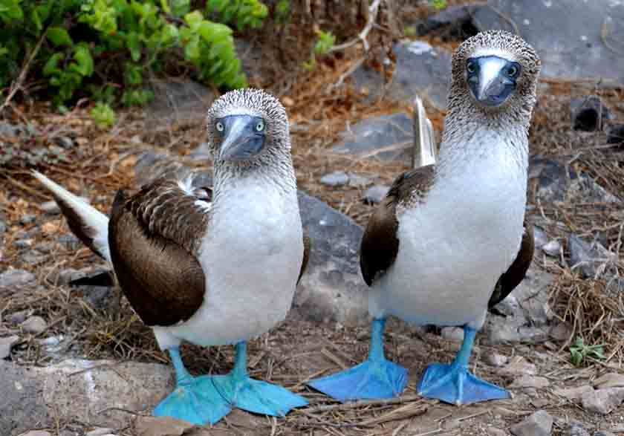

*Refference:*

https://academy.allaboutbirds.org/how-birds-make-colorful-feathers/